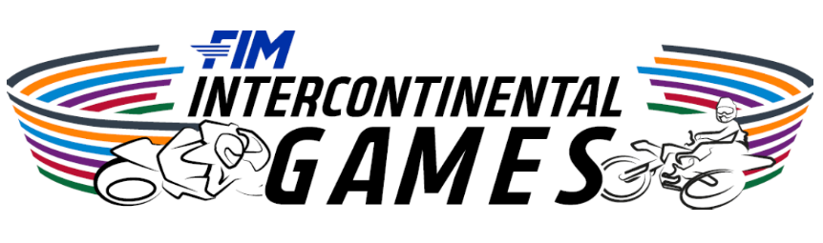


2026 FIM Intercontinental Games
Expressions of Interest – Team FIM Europe
The FIM Intercontinental Games (ICG) is back, and the next edition will be held at:
Autódromo Internacional Ayrton Senna, in Goiânia, Brazil from 10th to 13th December 2026.

After the huge success of the first FIM Intercontinental Games (ICG), the second edition is sure to be another great event once again focused on evaluating the sporting skill of the riders in a Team based competition for the six FIM Continental Unions (CONUs).

- FIM Africa
- FIM Asia
- FIM Europe
- FIM Latin-America
- FIM North-America
- FIM Oceania

The aim of the competition is to evaluate the CONU Teams over several disciplines in 2026, with Motocross now joining Circuit Racing in Goiânia, Brazil.

The ICG in 2026 will have competitions in Circuit Racing with two categories of Supersport 300 (SS300) and Supersport (SS) and Motocross Racing with MX2.

The 2026 edition at the Autódromo Internacional Ayrton Senna, in Goiânia, Brazil will be broadcast on Live TV thanks to the FIM platform and local broadcasters.

Team FIM Europe Rider Terms & Conditions -
All selected Riders for Team FIM Europe will be subject to the Terms and Conditions of the FIM, FIM Codes and policies, the policies and procedures of FIM Europe, and Terms and Conditions outlined in this document, and as advised by FIM Europe in the preparation and operations of the 2026 FIM Intercontinental Games.

CONU Teams Composition - Team FIM Europe
Teams will be represented by the colours of their CONU. In the case of FIM Europe we will be represented by the colour blue.
The riders of each CONU team will be selected by their CONU.

The number of CONU selected riders for both Circuit Racing and Motocross will be Four (4) per category (SS300, SS & MX2) inclusive of:
- One “Specialist Rider” designated as the CONU Team Captain and who may be currently competing in an FIM World Championship series during the 2026 year as a Permanent Rider.
- At least one female rider for each category (SS300, SS & MX2) who may or may not be competing in an FIM World Championship series during the 2026 year as a Permanent Rider.
- All other selected riders may not be currently taking part in any FIM World Championship series in 2026 as a Permanent Rider, as confirmed by the FIM Extranet.
- The riders must be holders of a FIM CONU Licence issued by one of the Federations who are a member federation of the CONU they represent.
- The riders must be holders of a passport of one country from within the geographic zone of the CONU they represent.
- Team FIM Europe will be coordinated by FIM Europe personnel, and at the event the team will be managed by a FIM Europe Team Managers (x2) = Circuit Racing and Motocross Team Managers, selected by FIM Europe.
- All selected Riders for Team FIM Europe will have their travel costs covered by FIM & FIM Europe *see details below (Travel)
- Team FIM Europe may nominate limited support personnel to attend the event in the role of mechanics, technicians or helpers. This will include 4x personnel for Circuit Racing and 4x personnel for Motocross. The travel for the nominated personnel will be covered by FIM & FIM Europe *see details below (Travel)

Team FIM Europe Rider Safety Apparel
All selected Riders for Team FIM Europe must wear the Rider Safety Apparel supplied by themselves. However, the Rider Safety Apparel must be supplied in the colours and design in accordance with the FIM supplied guidelines. No adjustment to the FIM design is permitted and this will be strictly enforced and require prior approval for each rider.
No other Rider Safety Apparel equipment will be permitted if not compliant to the FIM design.

Team FIM Europe Motorcycles
Circuit Racing:
All selected Riders for Team FIM Europe will be required to compete on the FIM supplied one-make Yamaha motorcycles for each category – (SSP300) Yamaha R3 & (SSP) Yamaha R7.
Each motorcycle will be race prepared ready by Yamaha Racing and available in the Pit Box on arrival at Autódromo Internacional Ayrton Senna - Goiânia, Brazil .
All Race & Pit Box Equipment – stands, tyre warmers, Beta Toolboxes, etc, are supplied and ready in the Pit Box upon arrival at Autódromo Internacional Ayrton Senna - Goiânia, Brazil.
Yamaha Racing Europe Technicians will be supplied by Yamaha Racing per CONU team.
Dunlop will be the Official Tyre Supplier and all required tyres will be supplied.
Panta Racing Fuel will be the Official Race Fuel and all requirements will be supplied.

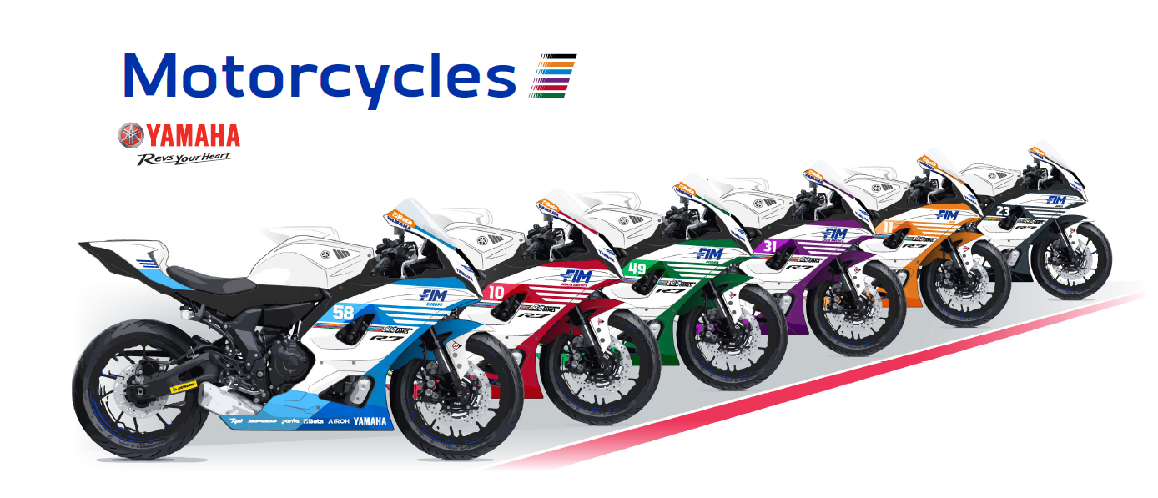
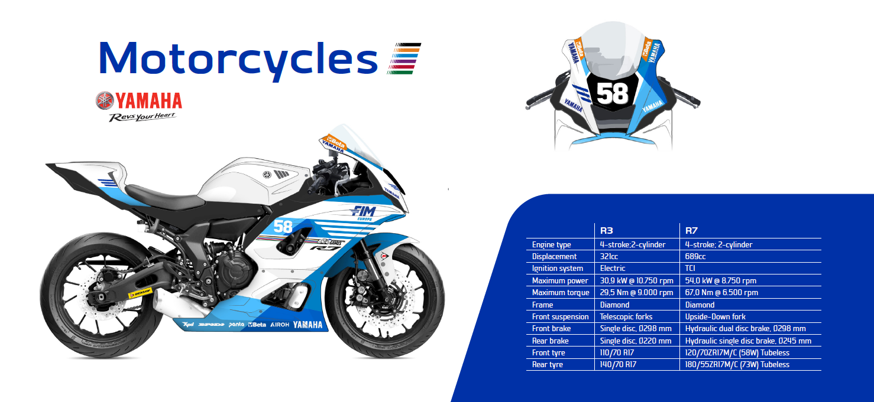
Motocross:
All selected Riders for Team FIM Europe must compete on the FIM supplied motocross motorcycles for the MX2 class using the selected brands as required.
Each motorcycle will be race prepared ready and available in the Pit Area on arrival at Autódromo Internacional Ayrton Senna - Goiânia, Brazil.
All Race & Pit Box Equipment – stands, Beta Toolboxes, etc, are supplied and ready in the Pit Area upon arrival at Autódromo Internacional Ayrton Senna - Goiânia, Brazil.

Team FIM Europe Travel
Each selected Rider for Team FIM Europe will be entitled to have their travel provided by FIM & FIM Europe.
Each selected Rider for Team FIM Europe will be required to travel on a team planned travel schedule. Riders based in Europe will be required to arrive at a similar time to the rest of Team FIM Europe.
Each selected Riders for Team FIM Europe will be provided with:
- Economy Class Return Airfare ** (Team Travel as approved by FIM Europe)
- Twin Share Accommodation in Goiânia, Brazil.
- Ground Transportation in Goiânia, Brazil – Group Travel (Bus or Vans)
- In Goiânia, Brazil - Daily Breakfast (Hotel), Lunch (Circuit) and Dinner (Hotel)
- Invitation to the Official FIM Intercontinental Games Function (Dinner)
Each selected Rider for Team FIM Europe will be required to provide their travel plan(s) upon request of FIM & FIM Europe.

Team FIM Europe Uniforms
Each selected Rider for Team FIM Europe will be supplied with a Team FIM Europe Uniform at no cost and will be able to keep this uniform after the event.
Each selected Rider for Team FIM Europe will be required to wear the Team FIM Europe Uniform at all times while at the circuit or representing Team FIM Europe at Official Activities, as advised by FIM or FIM Europe, except when wearing their official Rider Safety Apparel.
*Alternative Rider Cap/Hat may be permitted where this cap is non-conflicting to the event sponsor, and only with prior approval of FIM Europe.

Competition Regulations
The FIM Intercontinental Games – Circuit Racing (CCR) and/or Motocross (CMS) Regulations will be governed under the rules, regulations and enforcement of the FIM Intercontinental Games Regulations. These regulations will be enforced by the FIM Officials, ICG Race Direction and overseen by the FIM Stewards.
The FIM Intercontinental Games – Circuit Racing (CCR) and/or Motocross (CMS) Regulations will be based on the sporting and judicial regulations of the FIM World Championships.
Further information and availability of the FIM Intercontinental Games Regulations will be provided prior to the event.
A representative of FIM Europe will be included in the ICG Race Direction or FIM Stewards.
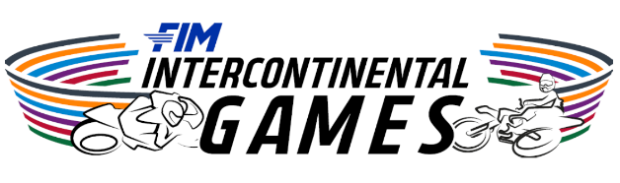

Expressions of Interest – Rider Application
Applications Close at 5.00pm (CET) on 8th June 2026
Riders First Name:
Riders Surname:
Date of Birth:
Federation:
National Licence Number and Expiry:
FIM/FIM Europe Licence Number and Expiry:
Address:
City / Town:
State:
Postcode:
Mobile:
Email:
Social Media Tag:
Passport Country and Nationality:
Passport Number:
Which City will you be departing from:
Nominated Mechanic / Technician or Helper:
Emergency Contact Name:
Emergency Contact Number:
List any notable career achievements:
Date Signed: Guardian Date & Signed (If under 18y/o):
Signed: Signed:

Please forward your Expression of Interest for consideration by the FIM Europe Commissions and FIM Europe Board.
Applications to be sent to – sport@fim-europe.com

